**Placement Empowerment Program**

***Cloud Computing and DevOps Centre***

Set Up a Virtual Machine in the Cloud Create a freetier AWS account. Launch a virtual machine and SSH into it.

Name: Jaswanth Saravanan

Department: ADS



**Introduction :**

The objective of this Proof of Concept (POC) is to explore the process of setting up a virtual machine in the cloud using the AWS Free Tier. A virtual machine (VM) is a crucial component in cloud computing, enabling users to deploy and manage scalable computing resources without requiring physical hardware. This POC serves as a foundational exercise for understanding cloud infrastructure and using AWS EC2 to create a simple and cost-effective computing environment.

**Overview**

This POC demonstrates the step-by-step process to:

1. Create a free AWS account.
2. Launch a virtual machine using AWS EC2.
3. Configure and secure the instance with a key pair and a security group. 4. Connect to the VM using SSH from a Windows system. The project covers basic tasks that are essential for beginners in cloud computing, offering hands-on experience with AWS infrastructure.

**Step-by-Step Overview**

Step 1:

1. Go to [AWS Management Console.](https://aws.amazon.com/console/)
2. Enter your username and password to log in.

Step 2 :

Navigate to the AWS Management Console and search for **EC2**.

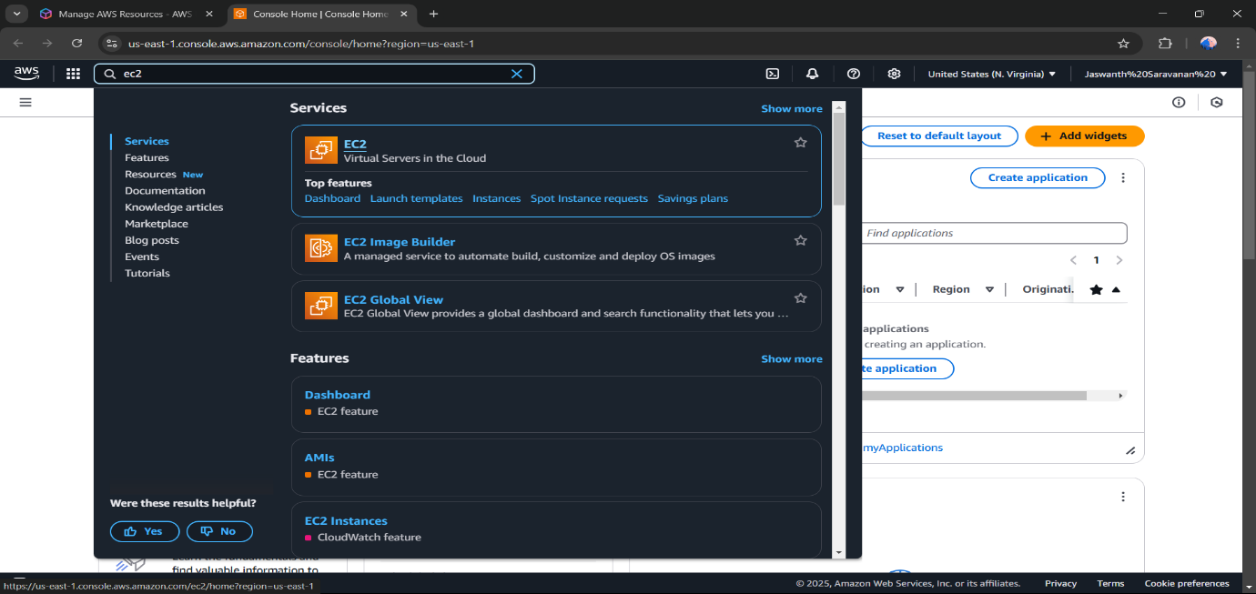

Step 3:

Click Launch Instance

Step 3 :

Add a new name for your instance , and select Amazon Linux aws by adding a tag and finally launch Instance .

Step 4 : 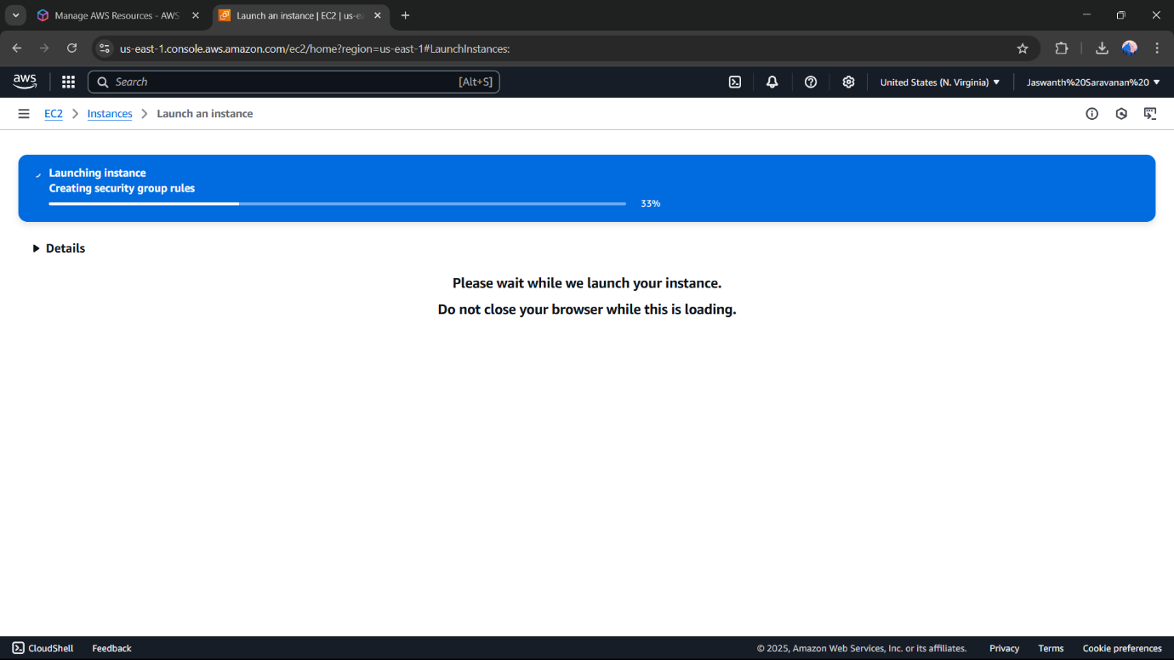

Step 5 :

Connect using EC2 instance Connect . 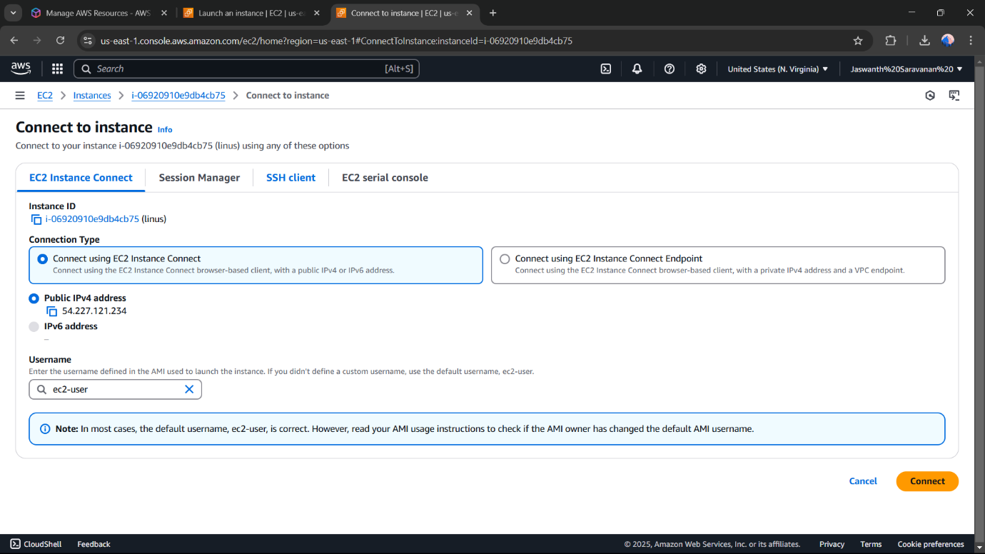

Step 6 :

Go to the SSH client section, and copy the command provided under the 'Example' section.

Step 7 :

Open PowerShell, navigate to the Downloads folder. Run the SSH command from the EC2 Connect section, replace the key name with your downloaded key press Enter, and type yes when prompted. 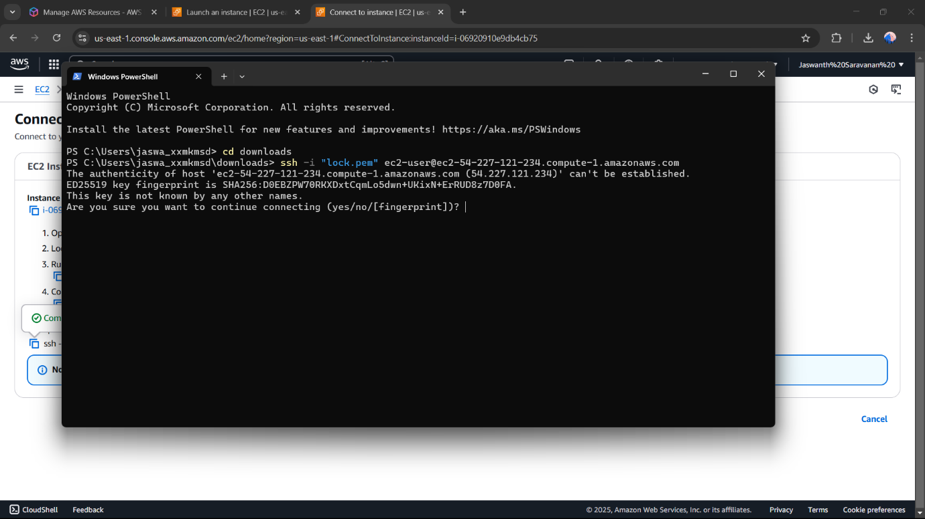

Step 8 :

Successfully completed the setup of a virtual machine in AWS.

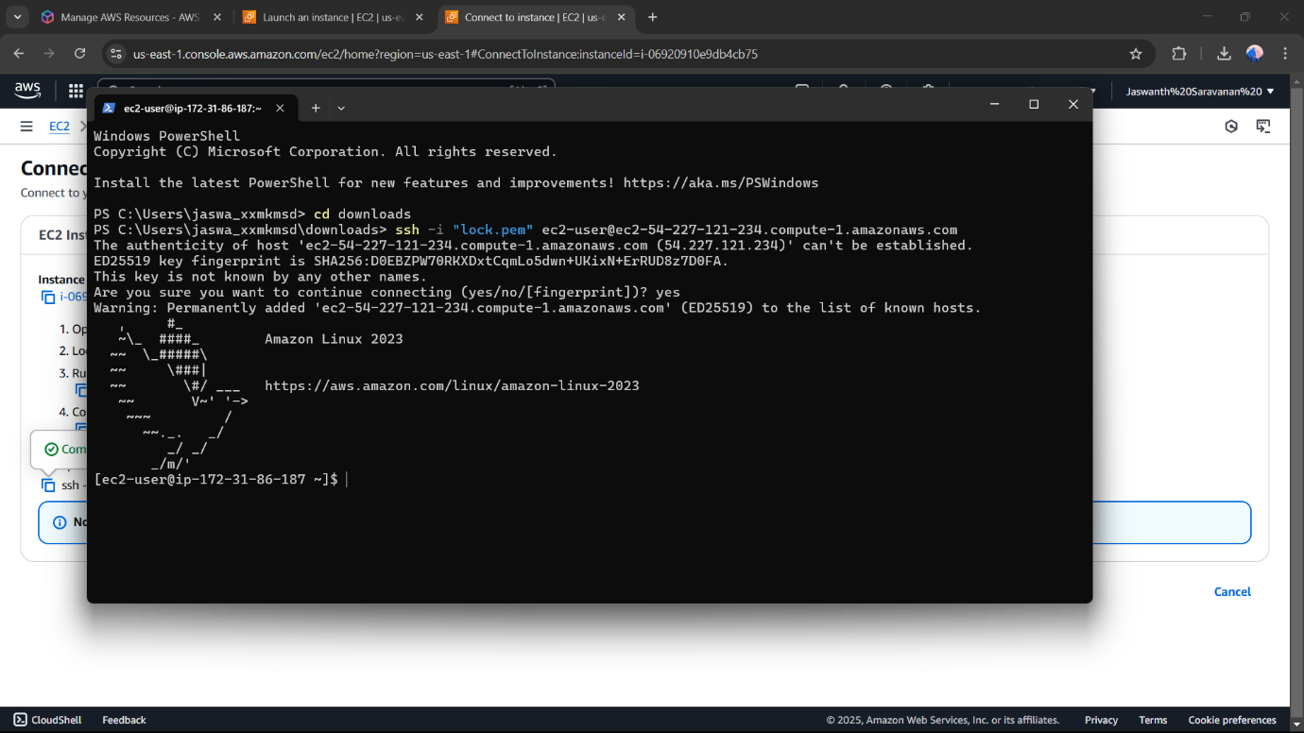

**Outcome**

By completing this PoC of setting up a virtual machine in AWS, you will:

1. Create and configure a free AWS account to use cloud resources within the Free Tier.
2. Launch an EC2 instance with Amazon Linux or Ubuntu as the operating system.
3. Generate and manage a secure key pair for SSH access to your EC2 instance.
4. Configure a security group to allow SSH connections to your instance from your IP address.
5. Successfully connect to the EC2 instance via SSH using the public IP address.
6. Gain hands-on experience with AWS EC2 and foundational cloud computing concepts.